Ex. No. 1 | TITLE OF THE EXERCISE
YouTube Link
Date of Exercise | DD.MM.YYYY

Aim
To illustrate the fundamental structure and control flow mechanisms of `while` loops in Python, demonstrating their utility for iterative execution based on a given condition.

Description
A `while` loop in Python executes a block of code repeatedly as long as a specified Boolean condition remains true. This control flow statement is essential for scenarios where the number of iterations is not predetermined, allowing for flexible repetition until a certain state or criterion is met. Key components include an initial condition, the loop body (indented code to be executed), and typically an update within the loop body that eventually alters the condition, preventing an infinite loop. `while` loops are widely used for tasks such as user input validation, implementing game loops, processing data streams, or performing algorithmic iterations that require dynamic termination. Python also provides `break` to exit the loop immediately and `continue` to skip the current iteration and proceed to the next, offering fine-grained control over loop execution.

Program
# --- Example 1: Basic while loop for counting ---
print("--- Basic while loop (counting) ---")
count = 0
while count < 5:
print(f"Count is: {count}")
count += 1
print("Loop finished.")
print("-" * 30)
# --- Example 2: while loop with break and continue ---
print("--- while loop with break and continue ---")
i = 0
while i < 10:
i += 1
if i == 3:
print(f"Skipping {i} with 'continue'")
continue # Skip the rest of the current iteration
if i == 7:
print(f"Breaking loop at {i} with 'break'")
break # Exit the loop entirely
print(f"Current value: {i}")
print("Loop with break/continue finished.")
print("-" * 30)
# --- Example 3: while loop for user input validation ---
print("--- while loop for input validation ---")
valid_input = False
while not valid_input:
user_input = input("Enter a positive number: ")
try:
num = int(user_input)
if num > 0:
print(f"You entered a valid number: {num}")
valid_input = True
else:
print("Invalid input: Please enter a positive number.")
except ValueError:
print("Invalid input: That's not a number.")
print("Input validation loop finished.")
print("-" * 30)

Output Screenshot
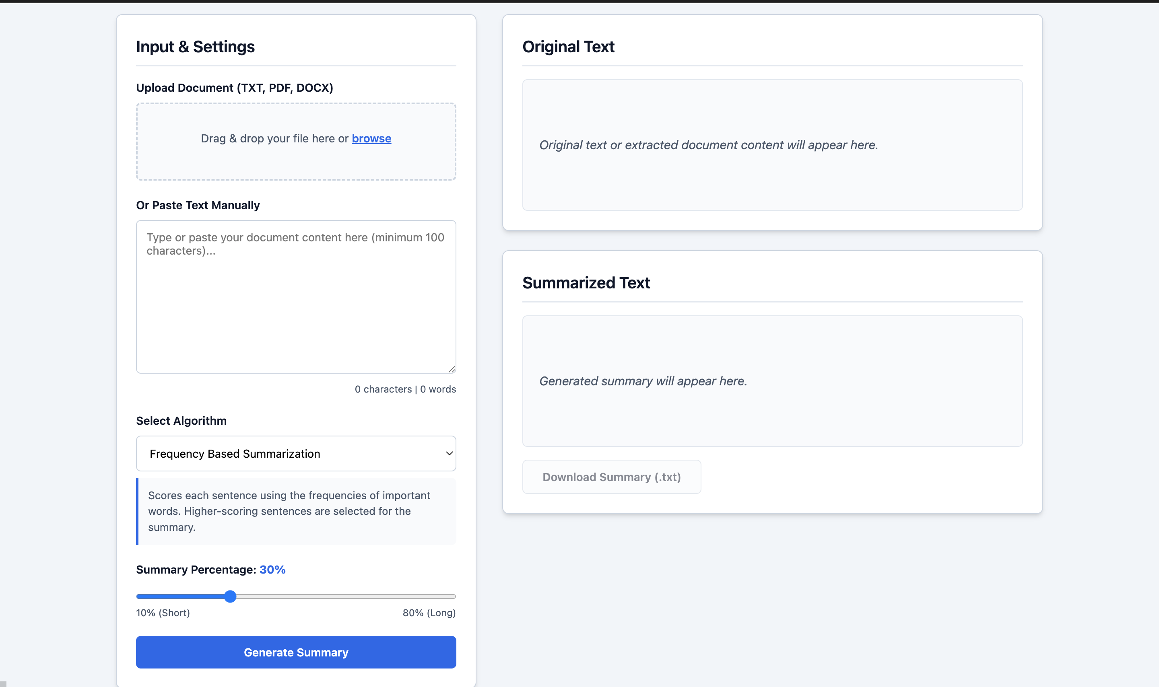

Result
The experiments successfully demonstrated the functionality of Python `while` loops, showcasing their use for controlled iteration based on a dynamic condition. The examples illustrated basic counting, the application of `break` for premature termination, `continue` for skipping iterations, and a practical scenario of user input validation. The objective of illustrating the fundamental structure and control flow of `while` loops was fully achieved.

